AWS Rekognition Tasks
1. Image Label Detection
- Use Rekognition to detect objects (e.g., car, person, dog)
- Output labels with confidence scores
Example use: “Detect objects in an image and list top 5 labels”

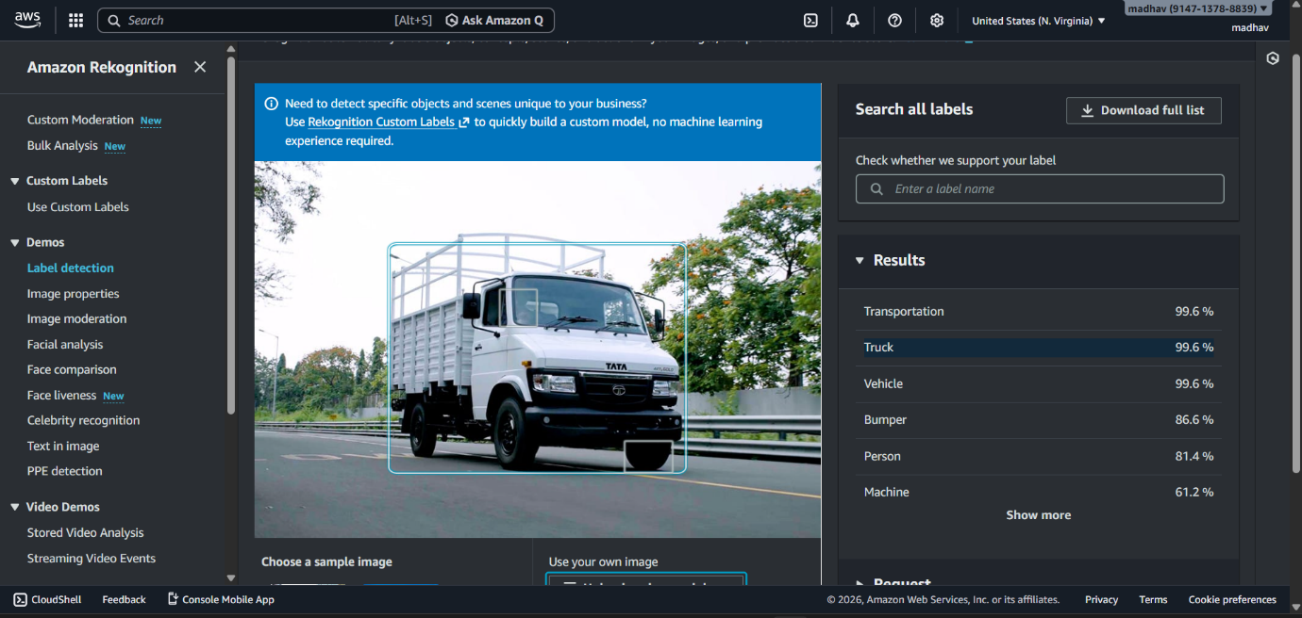

2. Face Detection & Analysis
- Detect faces in an image
- Analyze attributes like:
  - Age range
  - Gender
  - Emotions (happy, sad, angry)
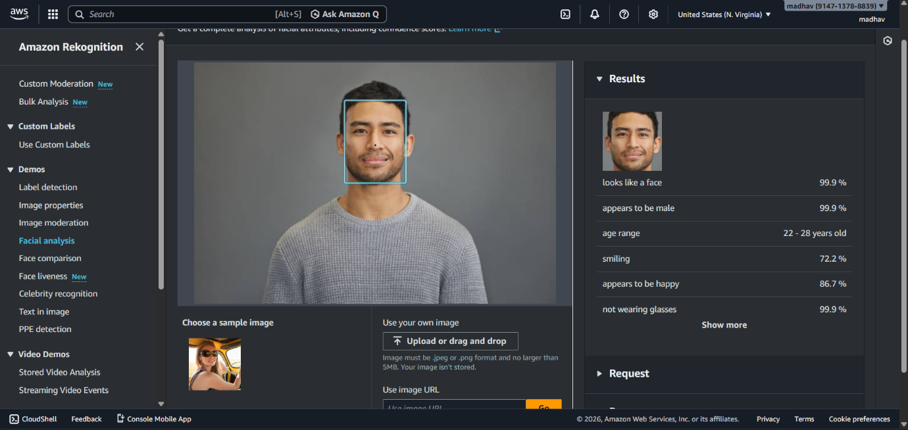

3. Face Comparison
- Compare two images
- Determine if the same person appears in both
- Output similarity percentage
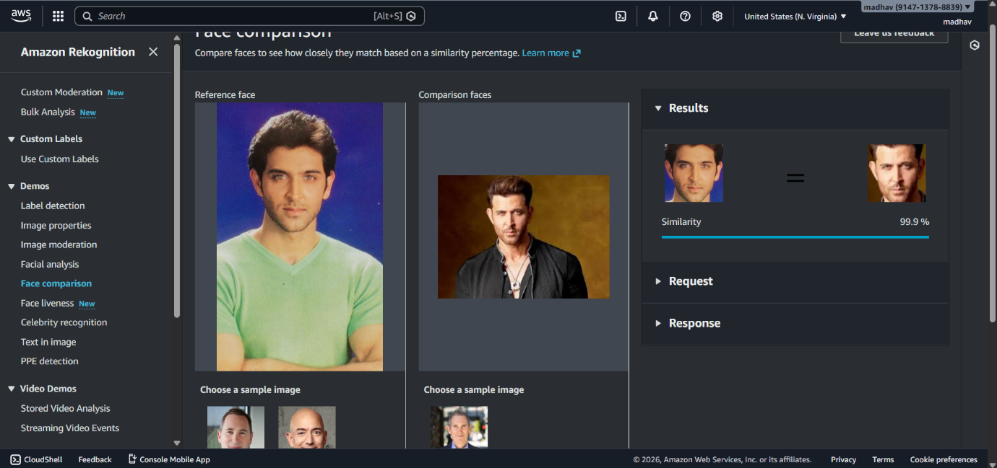

4. Text Detection
- Extract text from images
- Works on signboards, documents, screenshots
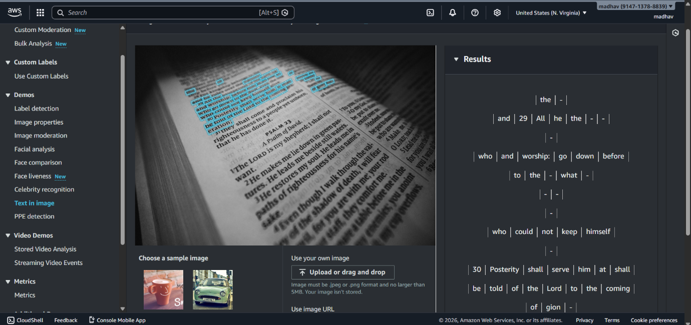

5. Celebrity Recognition
- Identify known public figures in an image
- Returns name + confidence score
